CP Club 365 Days Challenge

**Programming language – C++**

**Problem Statement**

<https://www.codechef.com/problems/RECENTCONT>

Git :- <https://github.com/Vedantbharad2603/CP_club_365_Days>

**Your Code**:

// 0x136Day of 0x365Days challenge

// VEDANT BHARAD

// 03-03-2023

#include <iostream>

#include <vector>

using namespace std;

int main() {

    // your code goes here

    int t;

    cin >> t;

    while (t--){

        int size;

        cin >> size;

        int a=0,b=0;

        while (size--){

            string code;

            cin >> code;

            if(code=="START38") a++;

            else b++;

        }

        cout << a <<" "<< b <<endl;

    }

    return 0;

}

**Output (Screen Shot)**:

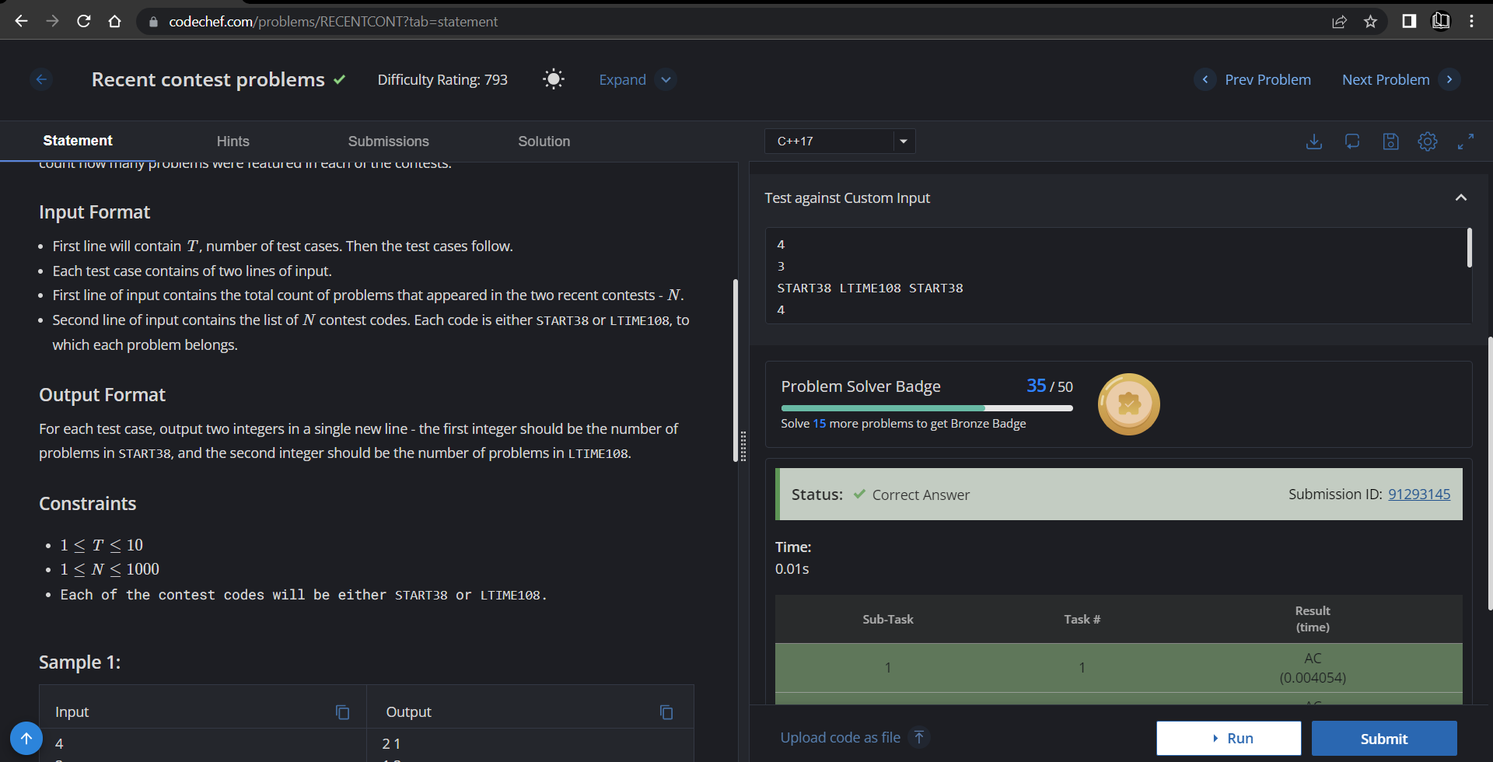

**Understanding about problem:**

* In this task I need to count “START38” and “LTIME108” given in input and return that count

Note: If you can't understand the problem, feel free to contact us and we'll help you. Please don't copy and paste from anywhere.

ALL THE BEST

Team CP Club